TWO DEGREE-OF-FREEDOM SYSTEMS
(Undamped Vibration)

Equation of Motion for a 2 dof Coupled System

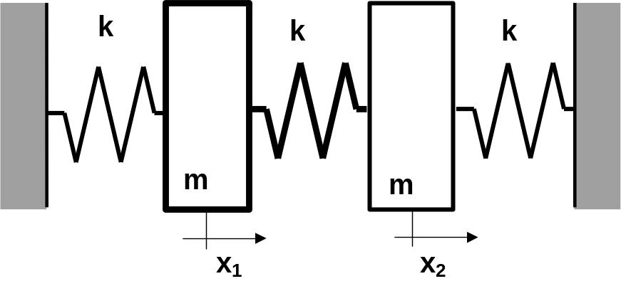

1 – Lagrange’s Equation

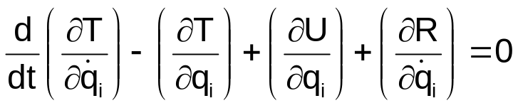
with:
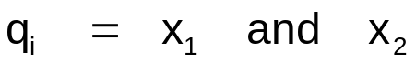

R = dissipation function (Rayleigh)
1 – 1 Kinetic Energy

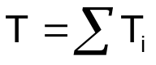
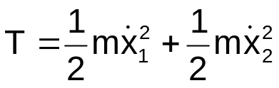

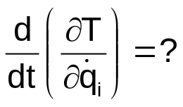
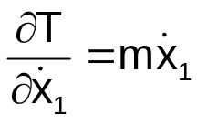
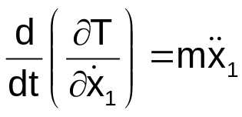
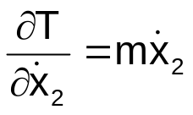
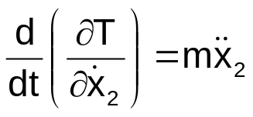
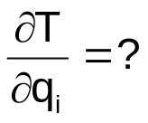
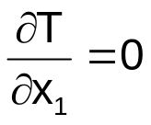
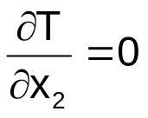
1 – 2 Potential Energy

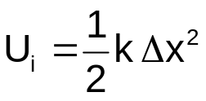
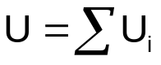

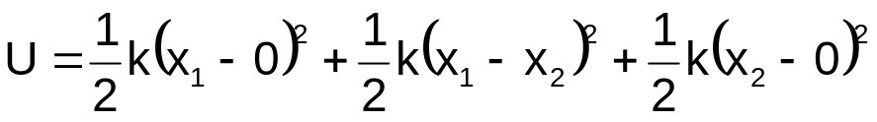
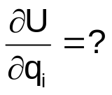

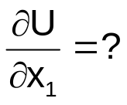
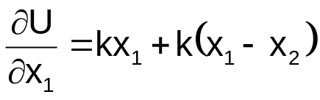
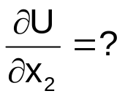
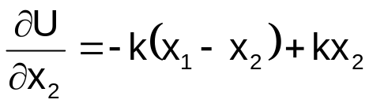
1 – 3 Equation of Motion (undamped)
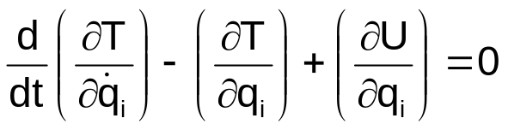

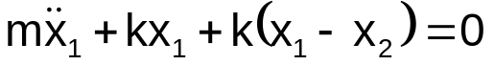
and
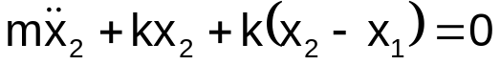

Mass matrix:

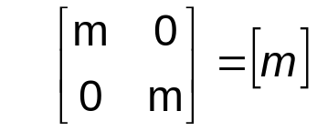
Stiffness matrix:
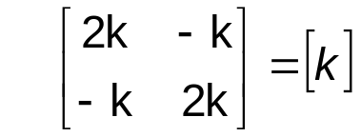

- both matrices are symmetric
- diagonal terms are positive
2 – Free Vibration
Natural Vibration of Coupled Systems

Coupling terms (static coupling)
Symmetric
Not Independent

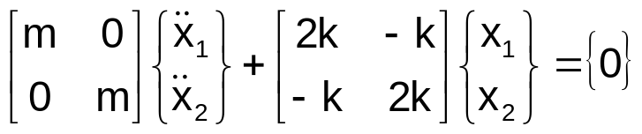

We try solution :
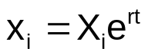

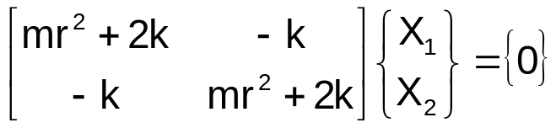
where 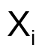are undetermined but 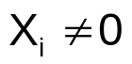

Frequency determinant leads to the frequency equation:
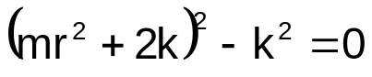
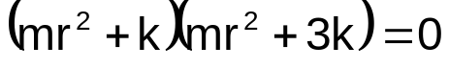

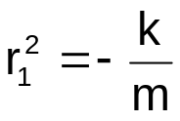 et 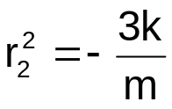
Natural Frequencies( eigenvalues)
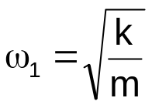 et 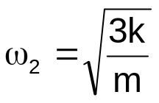

Natural Modes (eigenvectors)

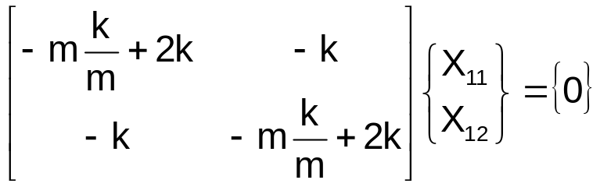

Two terms ➔ two relations:

first (or second) equation + norm
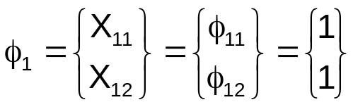
and
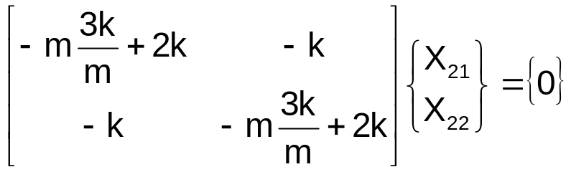

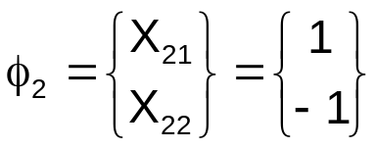
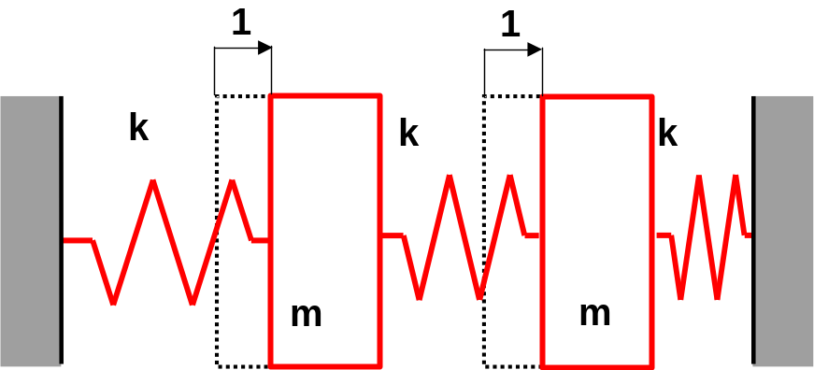
First Mode Shape

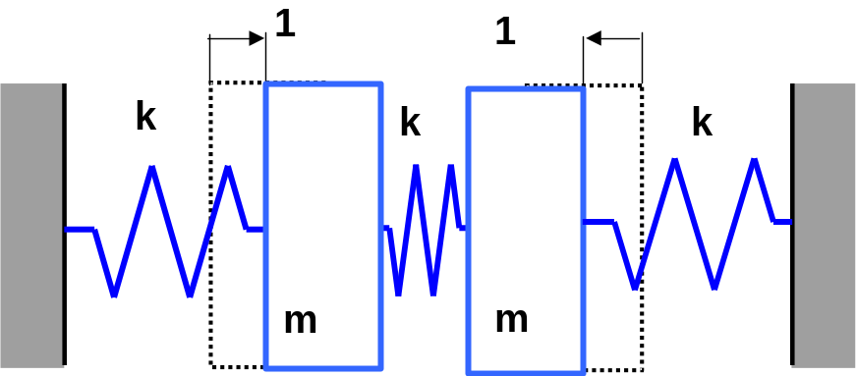
Second Mode Shape

Modal Matrix
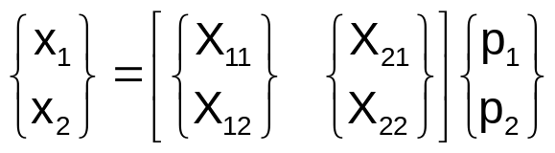
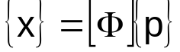
Linear transformation
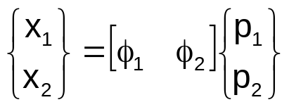

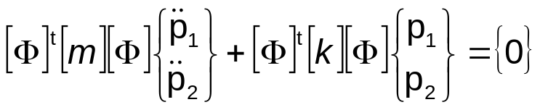

Modal Mass Matrix
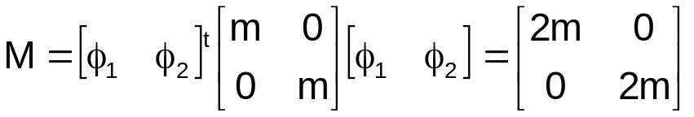

Modal Stiffness Matrix
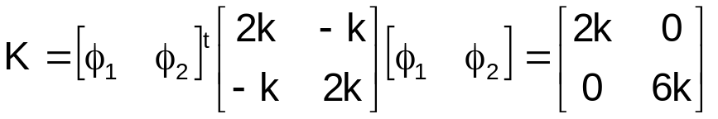
In a modal coordinate system

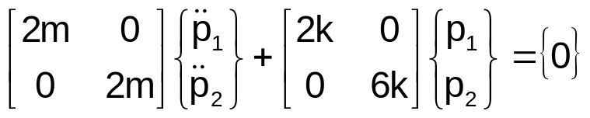

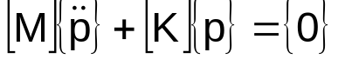

Equations are independent

Normal Form
both matrices are diagonal (uncoupled equations)
two separate one-degree-of-freedom systems

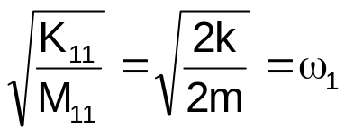 and 